
《High-level Language Programming Projec》Report

Project Name: Notes Management System

School : Computer Science and Engineering & School of International Education
Major : Computer Science and Technology Full English International Class
& Computer Science and Technology
Student Name : Yagin Alexandr, Bakbergen Amir, Bakbergen Alen, Zhalgasbayev Dinmukhamed
Teacher : Xuemiao Xu
Submission Date: 15.6.2025

Teacher comment | signature：  date：
Performance evolution
remark

1.1 Background and Motivation
The Notes Management System was created to address a straightforward issue: the majority of note apps on the market are either too complex, lacking essential features, or simply not intuitive. Our target was to develop a tool that genuinely functions as people would expect it to—one that is lightweight, useful, and simple to use.

After investigating user priorities, we discovered that simplicity, speed, and dependability are the most important factors. Cluttered interfaces, limited search capabilities, and the possibility of losing notes irritate people. Therefore, we concentrated on those problems and created a clear, quick, and simple system.

Professionals, students, and anybody else who needs to arrange their notes in an organized manner are the target audience for this system. The design prioritizes reducing the cognitive load on the user while offering dependable note storage and quick access.
1.2 System Objectives
To align with user needs, the Notes Management System aims to provide the following core functionalities:
- Seamless creation and editing of notes
- Persistent and secure storage
- Tagging and folder-based organization
- Automatic timestamp management for note creation and modification
- User-friendly interaction via CLI, with future GUI expansion
- Cross-platform compatibility (Windows, macOS, Linux)
These goals shaped our technical and architectural decisions to ensure high usability and future scalability.

2. System Design and Architecture

2.1 System Structure
The Notes Management System follows a three-layer modular architecture:
- Data Layer: Contains the Note class, representing each note’s title, content, tags, folder, and timestamps.
- Logic Layer: Encapsulated in the NoteManager class, this layer handles core business logic such as note creation, modification, search, and organization.
- Presentation Layer: Implemented as a Command-Line Interface (CLI), responsible for capturing user inputs and returning outputs through interactions with the logic layer.
This structured separation promotes ease of maintenance, clear modular responsibility, and flexibility for future improvements.

2.2 File Persistence Mechanism
File operations are handled by a dedicated File I/O module, using JSON and markdown formats for serialization. We used the nlohmann/json library for reliable and human-readable data storage. This design ensures persistent and structured note storage across sessions.
Advantages of this architecture include:
- High maintainability and clarity
- Scalable integration of new features
- Improved modular testing
- Flexible UI evolution with no impact on backend logic

3. Module Integration

3.1 Interaction Between Core Modules
Integration is carefully orchestrated through well-defined interfaces:
- The UI module interacts with NoteManager to perform CRUD operations.
- The NoteManager accesses the Data Layer to manage Note objects and uses the File I/O module for data persistence.
- The NoteManagerAdapter serves as a bridge between memory-resident data and disk storage formats, handling serialization tasks and abstracting underlying complexities.
This structure ensures low coupling, high cohesion, and readiness for future enhancements.

4. Functional Implementation

4.1 Core CRUD Operations
The system fully supports the CRUD paradigm:
- Create: New notes are created with user-provided titles, content, and optional metadata (tags/folder).
- Read: Retrieval options include by title, folder, tags, or general listings.
- Update: Notes can be edited and updates are automatically synchronized with persistent storage.
- Delete: Notes are removed from memory and disk in one operation to maintain integrity.
These operations are optimized for speed and reliability to support both casual and heavy users.

5. Class Structure and Logical Flow

5.1 Primary Classes and Functions
- Note Class:
  - Attributes: title, content, tags, created_at, updated_at, folder
  - Methods: Getters, setters, timestamp management
- NoteManager Class:
  - Responsibilities: CRUD, search, filtering, management of notes
  - Key Methods: createNote(), getNote(), updateNote(), deleteNote(), searchNotes()
- File I/O Module:
  - Key Methods: writeText(), readJson(), writeJson(), deleteFile()
  - Manages serialization using JSON
- NoteManagerAdapter Class:
  - Manages interaction between NoteManager and File I/O
  - Includes saveAll() and loadAll() for batch operations
- UI Module (CLI):
  - Captures user commands and interacts with NoteManager
  - Displays results and feedback
This structure ensures scalability, efficient logic execution, and low maintenance cost.

6. Testing and Evaluation

6.1 Testing Strategy
We used a multi-level testing approach to validate the system:
- Unit Testing:
  - Focused on methods in Note and NoteManager
  - Tested all edge cases for serialization/deserialization
- Integration Testing:
  - Validated communication between File I/O and NoteManager
  - Ensured accurate synchronization of memory and disk data
- System Testing:
  - Simulated real-world use cases
  - Evaluated UI response, error handling, and robustness
All tests confirmed that the system meets design and functional specifications.

7. Personal Reflection
Working on the Notes Management System provided valuable insights into C++ programming, software architecture, and real-world application of file I/O and interface design. The challenges in synchronization and modular integration taught me to approach development systematically and with clear separation of concerns. This project significantly contributed to my growth as a software developer.

8. Future Development Plan
To extend the system’s usability and appeal, the following features are planned:
- Graphical User Interface (GUI) for broader accessibility
- Encryption features to secure sensitive information
- Cloud synchronization for multi-device accessibility
- Versioning and advanced search algorithms for better organization and tracking
These enhancements will align the system with modern user needs and further solidify its position as a robust, user-centric tool.

9. Graphical Interface Features & ZIP Archive Summary

9.1 Detailed GUI Screenshots and Feature Descriptions

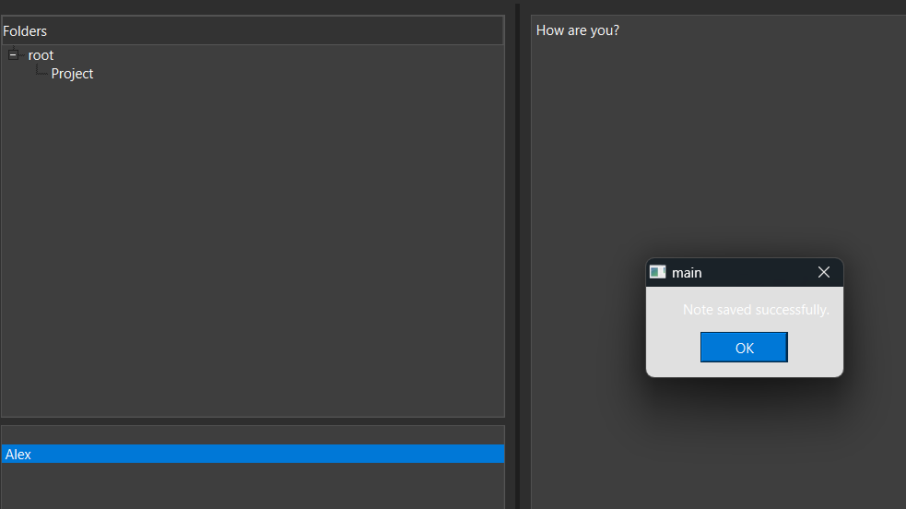
Main Interface – Note saved successfully popup

This screenshot shows the main working area of the app. On the left side, there’s a folder tree using QTreeWidget where users can organize notes into folders — here, for example, we have root and a subfolder called Project. Below that, the QListWidget shows the list of notes under the selected folder (in this case, a note titled Alex).
The right side is the main editor area (QTextEdit) where users can write and update the content of their notes — here we have the text "How are you?". When a user clicks save, the app shows a small QMessageBox popup that confirms: "Note saved successfully."
This feedback is important because it tells the user the note has been safely stored, both in memory and on disk via our file I/O system using JSON. It adds a layer of reassurance without interrupting the workflow.
We implemented this using:
- saveNote() slot connected to the Save button or Ctrl+S,
- QMessageBox::information() for the popup,
- The logic syncs both in-memory note updates and writes them to disk using our FileIO::writeJson() method.
Overall, this screen shows the basic but functional layout of our app — fast access to folders and notes, a clean editor, and responsive feedback.

Advanced Search Dialog
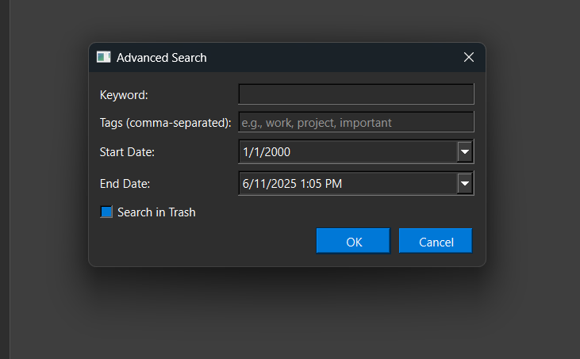
This dialog uses multiple input widgets such as QLineEdit for keywords, QDateTimeEdit for date ranges, and QCheckBox for trash search. It is implemented using a `QDialog` with `QFormLayout` to align the label-field pairs. The "OK" button triggers the performAdvancedSearch() function, which talks to the NoteManager and filters notes using the conditions the user entered. All search logic is done in memory but based on the saved JSON data structure.
This feature adds a powerful layer for users who work with lots of notes and need quick, precise results. It improves usability a lot, especially when compared to simple text-based search.

Settings Dialog
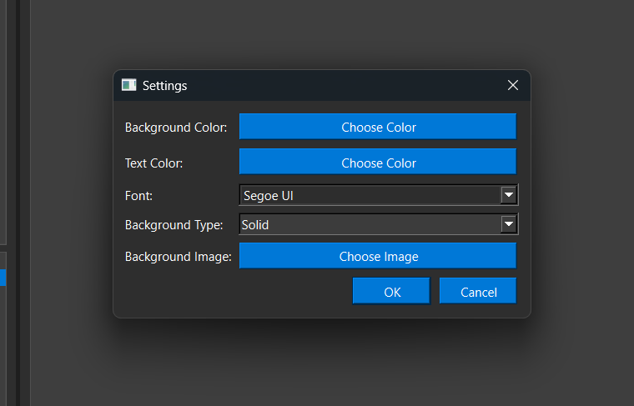
This is the Settings window where the user can fully customize how the app looks. It’s a QDialog built with a vertical layout and several interactive elements.
What can be changed here:
- Background Color and Text Color via QColorDialog::getColor()
- Font using a QFontComboBox
- Background Type: solid color or image (via dropdown with values like "Solid", "Image", etc.)
- Background Image using QFileDialog::getOpenFileName() to load a local file
Once the user sets their preferences, the applyStyles() function updates the main window’s palette and font using QPalette and QFont. The configuration is saved using QSettings, so everything is restored automatically when the app is reopened.
This dialog helps users personalize the interface the way they want. Whether someone prefers light mode, dark mode, or even a background image — it’s all possible with just a few clicks.

Color Picker Dialog
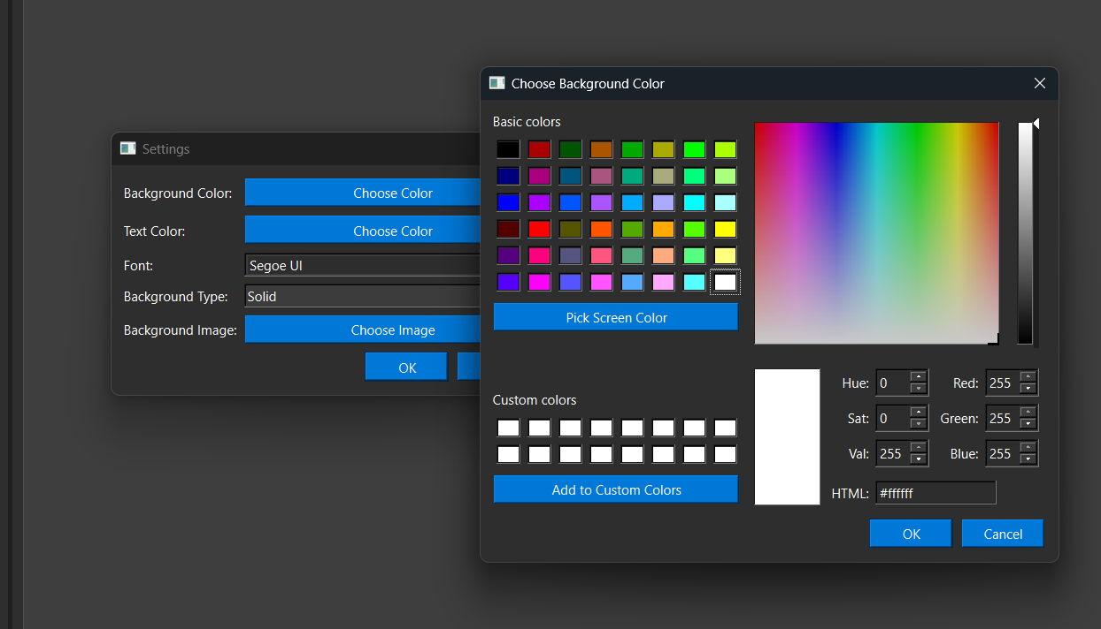
Here, the user is picking a color using the standard Qt color dialog (QColorDialog). This dialog shows up when you click “Choose Color” in the settings window — either for background or text.
The interface provides:
- A big palette with basic colors
- A color gradient for precise selection
- Sliders and input fields for RGB, HSV, and even HTML hex values (like #ffffff)
- A “Pick Screen Color” tool for grabbing any color from the screen
Once the user selects a color and clicks OK, the chosen color is applied using QPalette::setColor() either for the background or the text role. This change updates the main window immediately and is saved in QSettings, so the style persists even after restarting the app.
This dialog is a small but important part of giving users full control over how their app looks — and it’s all done with just a few lines of code thanks to Qt’s built-in tools.

Rename Note Dialog
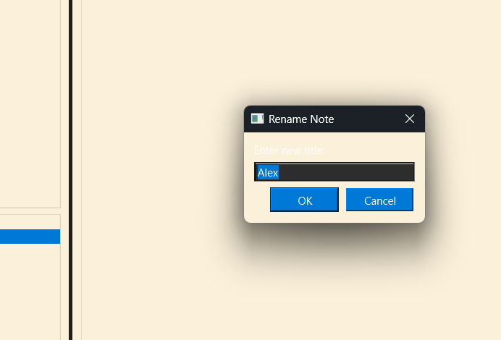
This small dialog is used to rename the currently selected note. It is implemented via a simple `QDialog` with a `QLineEdit` and two buttons (`QDialogButtonBox`). The new title is validated and applied to the selected note object in the NoteManager upon pressing OK.

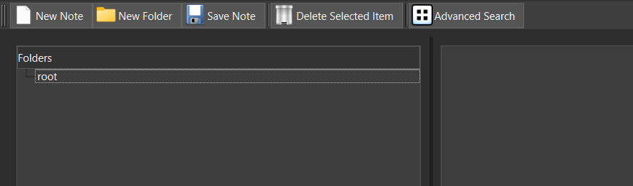
Toolbar Interface

This part of the app is the top toolbar, built using QToolBar. It gives users quick access to the main actions without digging through menus.
The buttons here include:
- New Note – calls createNote()
- New Folder – calls createFolder()
- Save Note – connected to saveNote() and also mapped to Ctrl+S
- Delete Selected Item – removes a folder or note depending on what’s selected
- Advanced Search – opens the advanced search dialog with filters
Each button uses QAction with icons loaded through QIcon(":/icons/..."). The icons help keep the UI clean and user-friendly. All actions are connected to corresponding slots in the UI layer, which then talk to NoteManager to actually perform the operations.
Overall, this toolbar helps speed things up and makes the app feel smooth and modern. Most common actions are just one click away.

Hotkeys Help Window
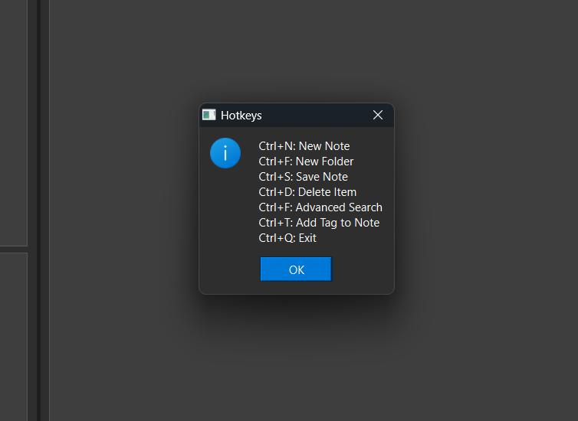
This popup is shown using `QMessageBox::information` and displays registered hotkeys handled using `QShortcut` objects. The hotkeys are registered to the main window and bound to QAction or QWidget slot functions to enhance usability.

9.2 Summary of Final Project
Project Purpose

The Notes Management System was designed to provide a lightweight, easy-to-use application for organizing, editing, and managing notes. It solves common issues found in other apps, such as complicated UI, missing tagging/search features, and poor integration. Target users include students, professionals, and anyone needing structured note management.

Core Features

- Folder and note structure: Tree-style folder system and individual note handling via QTreeWidget, QListWidget, and QTextEdit.
- Advanced Search: Keyword, tag, and date-range filtering with an option to search in trash.
- Tag system: Notes can be tagged with comma-separated keywords.
- Settings customization: Users can change background/text color, font, and background type (solid or image).
- Color Picker: Integrated QColorDialog for personalized themes.
- Hotkeys support: Fast access with Ctrl+N/F/S/D/F/T/Q.
- Persistent storage: JSON-based file I/O using nlohmann::json.
- Modular structure: Split into Note, NoteManager, FileIO, Adapter, and UI layers.
- Qt6 GUI: Cross-platform desktop application using Qt 6 widgets and dialogs.

Technologies Used
- Language: C++17+
- Framework: Qt 6 (Widgets, Dialogs, Events)
- Serialization: nlohmann::json
- Persistence: Local file system (JSON)
- Cross-platform Build: Makefile + Qt build system
- Styling: QPalette, QFont, QSettings

Planned Features (Future Work)
- Cloud sync for multi-device access
- Version control and history tracking
- Export to Markdown or PDF
- Implement AI into notes app

